# Homework 2 Number systems, ASCII and Unicode

1. Computers make extensive use of the binary number system.
   1. In an 8-bit computer system, explain how to determine how many different decimal values can be represented. [2]

Add the value of every bit, then +1 at the end

For example:

128 64 32 16 8 4 2 1

= 128 + 64 + 32 + 16 + 8 + 4 + 2 +1 = 255

255 + 1 = 256

256 values

Add 1 because 00000000 is also a combination

* 1. When voltage changes in a circuit it often takes time to settle to a constant level as shown in the graph below:

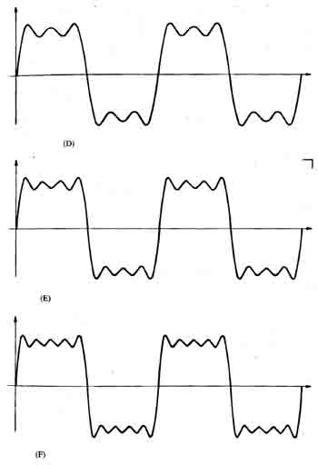

Explain why, in a computer system using binary, this effect is not an issue. [2]

Binary only uses 0 and 1s its like an on and off switch so the moment it detects a change it will switch.

1. A company runs a website where users can upload videos about sport. Users register from all over the world.
   1. The database storing the videos has grown to 2,407,117,015 bytes.   
        
      What is this value expressed in GB, rounded to 1 decimal place? [2]

**2.4 GB**

* 1. The database is expected to grow in the next year to 1030 GB. A new hard disk to store the database is required.

Show that a 1 TiB hard disk would be able to store a database of this size. [2]

1 TiB = 1099511627776 bytes

1099511627776/1000000000 = 1099.5 GB

1099.5 GB > 1030 GB

* 1. The database uses Unicode character encoding to store details about the videos.  
       
     Describe one reason for this choice. [1]

Unicode character encoding has a large variety of characters compared to other character sets meaning you can store different languages’ characters, so if someone is viewing the details in Russian, they can view it in their language without having to translate it from, for example, English to Russian.

3. The 7-bit ASCII representations of the digits 0-9 are 011 0000 to 011 1001.

(a) What is the ASCII representation of the number 3? [1]

011 0011

(b) Convert this representation to denary. [1]

1 + 2 + 16 + 32 = 51

(c) The 7-bit ASCII representations of the letters A – Z are 100 0001 to 101 1010.

Represent the word BEAD in binary in a 32 bit byte. [3]

100 0010 100 0101 100 0001 100 0100

[Total 14 Marks]